**GROUP ASSIGNMENT – MEETING MINUTES**

|  |  |
| --- | --- |
| **Module Name** | CSCK501 Global Trends in Computer Science June 2025 A |
| **Assignment Name** | Mid-Module Assignment Poster Presentation |
| **Assignment Due Date** | Monday, 14 July 2025, 11:59 PM |
| **Team Name** | STV Synergy |

Please, list your team members’ names in the table below and their respective roles.

Depending on the project, roles could be represented by specific tasks (i.e., tests/reviews), sections (i.e., poster sections), or anything else that explicitly identifies what each member is assigned to.

This document can be used for both synchronous (live/ real-time) and asynchronous collaboration.

|  |  |
| --- | --- |
| **Full Name** | **Role / Tasks** |
| Theresa Strydom | Take minutes. Draft section, check references, write script |
| Salman Bahammam | Set meetings, draft section, canva layout, check script |
| Vinda Zoebir | Tech info, draft section, canva layout, check script |
|  |  |
|  |  |

|  |  |  |  |
| --- | --- | --- | --- |
| **1. Meeting info** | | | |
| **Date of Meeting (or reporting deadline)** | 26/06/2025 | **Time [UK] (or reporting deadline e.g. 23:55)** | 12:00 |
| **Location (VLE, Teams Chat for asynchronous)** | Teams | **Minutes prepared by** | Theresa |

|  |
| --- |
| **2. Meeting Objective (task completion, challenges, future tasks)** |
| Get everyone on the same page:  **Agreeing on our exact topic** (e.g. AI-driven co-play in palliative care)  **Walking through the assignment brief** so we understand deliverables  **Outlining the poster structure** and key sections  **Assigning roles & responsibilities** for each section and support tasks  **Setting our mini-deadlines** and scheduling the next meeting |

|  |  |
| --- | --- |
| **3. Attendance (or reporting progress from team members within 24h window before deadline)** | |
| **Full Name** | **Present (reported) / Not present (did not report) / Sent apologies** |
| Theresa Strydom | Present |
| Salman Bahammam | Present |
| Vinda Zoebir | Present |
|  |  |

|  |  |  |
| --- | --- | --- |
| **4. Agenda and Notes, Decisions, Issues** | | |
| **Topic** | **Owner** | **Notes** |
| **Review Assignment Brief & Deliverables (10 min)**   * Confirm understanding of:   + A1 PDF poster (≤ 1 000 words, A1 size)   + 10-minute video presentation   + ≥ 3 mini-meeting minutes   + Individual peer assessment form | Theresa | Review the Peer Assessment Form to ensure we meet all the required criteria.  **Poster = Key Points Only** • Use bullets, headings and simple graphics to convey your main messages. • Keep text to the essentials (e.g. “Co-play sessions reduce carer stress”). • Design it so someone walking by can grasp your core ideas in 30 seconds.  **Video = In-Depth Explanation** • During your 10-minute talk, you expand on each bullet: share data, anecdotes or clinical examples that wouldn’t fit on the poster. • You can illustrate mechanisms (e.g. how the AI adapts in real-time) or unpack ethical nuances verbally. • zoom into a section of the poster on screen to guide viewers’ focus as you dive deeper.  No new visual content |
| **Topic Selection (10 min)**   * Finalise exact wording of chosen topic | Salman—our palliative-care doctor—will provide the expert critique and final refinements. Therefore, Vinda (gamer) and I, Theresa (philosopher), will introduce some ideas first, after which Salman will extend, critically review and fine-tune our proposals. | AI and gaming immersive, carer and palliative care patients.  Vinda- Critical: Raptor AI, interact with a character but this lead to suicide of a teen.  TS: Carer coud be considered in the AI  SB: Carer burnout may be important, may not have any published work, AR available for patients experience, good idea to combine this with the carer needs. Already studies for vitals and discomfort, from immersive computing. Patient and family could go on a cruise.  Everything is focused on the patient, not carer/family/friends.  TS: Vindas point shows that we should not focus on only patient- should have regulating by another human  SB: the other person ties it back to reality, AI only as a functional tool not as a character  VZ: VR is more focused on patient/one person.  SB: qs: is there any tech that could have a group inside the same VR space?  VZ: meta have an ambitious plan to create a meta world. SB will look.  SB: huge gamer, ad: VR experience for groups, like roblox, so tech might be there. Could be private groups for patients and caregivers. |
| **High-Level Poster Outline (10 min)**   * Walk through proposed sections:   + Introduction   + Background & Technology   + Patient Applications   + ….   + Ethics & Practicalities   + Future Outlook   + Conclusion & References * Agree any tweaks or merges | Salman, Vinda, Theresa | * + Introduction (100)   + Background & Technology (150)   + Patient Applications SB: not all patients may be able to participate- are there work arounds? SB: What are a patient abilities/goals,patient-tailoring? (200)   + SB: Product proposal (250)   + Ethics SB: have to talk about it & Practicalities SB: after product, consider raptor AI case. (150)   + Conclusion (100)   + & References |
| **Roles & Responsibilities (10 min)**   * Assign primary leads for each section (e.g.– Intro & Background,– Patient Apps & Ethics,–Engagement & Future) * Confirm who will:   + Take meeting minutes   + Manage references list   + Set up shared folder/Drive/Trello board |  | * + TS: Introduction (100)   + SB: MEdical Background & VZ: Technology (150)   + SB: Patient Applications SB: not all patients may be able to participate- are there work arounds? SB: What are a patient abilities/goals,patient-tailoring? (200)   + VZ: Product proposal (250)   + TS: Ethics SB: have to talk about it & Practicalities SB: after product, consider raptor AI case. (150)   + TS: Conclusion (100)   + & References   TS: Minutes  SB: setup next meeting: next week, towards the end  Shared document on onedrive |
| **Communication & Collaboration Tools (5 min)**   * **Agree on:**   + **Group chat (Teams channel vs WhatsApp)**   + **Document repository (OneDrive folder)**   + **Poster template (PowerPoint)** |  | TS: Keep chatiing on Whats and Teams.  Upoaded doc on teams,  Upload power point on teas to share  Upload each section on teams.  VZ and SB: use Canca for poster |
| **Next Steps & Mini-Meeting #2 (5 min)**   * **By 25 Jun: each member to draft 250–350 word sub-section** * **Schedule Meeting #2 for 26 June, 14:00 GST to review drafts?** * **Confirm minutes format and where to upload** |  | Deadline: 25th of June for draft sections. Next Meeting 26th June: UK: 10AM, GMT 9AM |
| **AOB (Remaining time)**   * **Any other questions or concerns?** |  | WE will do our homework :) |
| *The “Notes” column should include a summary of the discussion had about the topic and any decision taken.* | | |

|  |  |  |
| --- | --- | --- |
| **5. Action Items** | | |
| **Action** | **Owner** | **Due Date** |
| * + SB: Medical Background & VZ: Technology (150) | SB medical  VZ: Background | 24/06/2025 |
| * + SB: Patient Applications SB: not all patients may be able to participate- are there work arounds? SB: What are a patient abilities/goals,patient-tailoring? (200) | SB | 24/06/2025 |
| * + VZ: Product proposal (250) | VZ | 24/06/2025 |
| * + TS: Ethics SB: have to talk about it & Practicalities after product, consider raptor AI case. (150) | TS | 24/06/2025 |
| TS: to write introduction, conclusion and format references | TS | 30/06/2025 |
| *The “Action” section must include the action(s) that the “Owner” (the student assigned to complete the action) must complete by the due date.* | | |

|  |  |  |  |
| --- | --- | --- | --- |
| **6. Next Meeting (or reporting deadline)** | | | |
| **Date** (DD/MM/YY) | **26/06/2025** | **Time [UK]** (HH:MM) | **10AM** |
| **Location** | Teams | | |
| **Objective** | Review draft. | | |
| *Unless this minutes refers to the last one before submission, students need to identify date, location and objective of the next meeting/ reporting deadline before concluding the current meeting/ reporting deadline.* | | | |

|  |  |  |  |
| --- | --- | --- | --- |
| **1. Meeting info** | | | |
| **Date of Meeting (or reporting deadline)** | 22/06/2025 | **Time [UK] (or reporting deadline e.g. 23:55)** | 9:00 |
| **Location (VLE, Teams Chat for asynchronous)** | Teams | **Minutes prepared by** | Theresa |

|  |
| --- |
| **2. Meeting Objective (task completion, challenges, future tasks)** |
| * **Confirm product concept and poster structure** * **Review and integrate individual draft sections** * **Assign clear tasks and mini-deadlines** * **Agree on required diagrams/graphics and ethics framing** * **Schedule next check-in and meeting minutes responsibility** |

|  |  |
| --- | --- |
| **3. Attendance (or reporting progress from team members within 24h window before deadline)** | |
| **Full Name** | **Present (reported) / Not present (did not report) / Sent apologies** |
| Theresa Strydom | Present |
| Salman Bahammam | Present |
| Vinda Zoebir | Present |
|  |  |

|  |  |  |
| --- | --- | --- |
| **4. Agenda and Notes, Decisions, Issues** | | |
| **Topic** | **Owner** | **Notes** |
| 1. **Welcome & Attendance** (2 min)    1. Record who’s present, who’s apologies 2. **Recap of First Meeting Outcomes** (5 min)    1. Topic selection, initial literature sources, chosen software tools | Theresa | All present |
| 1. **Finalize Product Description** (10 min)    1. AI-guided VR “experience” vs “guide” terminology    2. Modes: standalone AI guide vs shared patient–carer sessions | All | Guided experience by AI.  Botj AI and shared patient- carer guided experience |
| 1. **Poster Section Structure** (10 min)    1. Introduction & background    2. Product proposal (system diagram + flowchart)    3. Ethics & safeguarding    4. Future trends & conclusion    5. References (Harvard style) | SB  VZ | * + Agreed framework   + Introduction (100)   + Background & Technology (150)   + Patient Applications table SB (200)   + SB+V- diagram and text: Product proposal (250)   + Ethics SB: have to talk about it & Practicalities SB: after product, consider raptor AI case. (150)   + Future trends & Conclusion (100) What products could aim for. Consider Black mirror- but positive, Ai will be better in a few years. AI can learn from these palliative care experience, facial expression, vitals to build on the knowledge of AI.   + & References |
| 1. **Literature Draft Review** (10 min)    1. Salman’s background draft (135 words)    2. Vinda’s system diagrams and flowchart (150 words)    3. Theresa’s ethics bullets (draft outline) | TS | Flowchart could go in the appendix.  TS: to go over whole essay and check for coherence and write intro and conclusion. |
| 1. **Graphics & Layout Discussion** (5 min)    1. Which figures to include (e.g. System Overview, User Journey)    2. Whose responsibility for diagram creation | VZ  SB | V+S to do Canva layout. Colour agreement: same as liverpool logo. V will make flowcharts in colout. |
| 1. **Task Assignment & Mini-Deadlines** (10 min)    1. Divide remaining word count (max 1000 words) among members    2. Set three checkpoints before 14 July:       1. **Checkpoint 1 (30 June):** Complete full draft in PDF template       2. **Checkpoint 2 (7 July):** Finalise diagrams, review language/word-count       3. **Checkpoint 3 (11 July):** Proofread, embed references, freeze layout 2. **Video Presentation Planning** (5 min)    1. Who records which segment    2. How to highlight poster visuals (zoom-ins) 3. **Agree Next Meeting & Minutes** (3 min)    1. Propose next meet: **2 July at 15:00 Dubai time**   Assign minute-taker for next meeting | TS | Draft attached – Appendix 1 |
|  |  |  |
| *The “Notes” column should include a summary of the discussion had about the topic and any decision taken.* | | |

|  |  |  |
| --- | --- | --- |
| **5. Action Items** | | |
| **Action** | **Owner** | **Due Date** |
| Make wriritng coherent, intro and conclusion | TS | 02/07/2025 |
| FLowcharts in colour | VZ | 2/07/2025 |
| Add a table to patient section | SB | 2/07/2025 |
| Make Canva poster | VZ+SB | 7/07/2025 |
| Write speech and time yourself | TS,VZ,SB | 6/06/2025 |
| Go over draft and recording | TS | 08/06/2025 |
| *The “Action” section must include the action(s) that the “Owner” (the student assigned to complete the action) must complete by the due date.* | | |

|  |  |  |  |
| --- | --- | --- | --- |
| **6. Next Meeting (or reporting deadline)** | | | |
| **Date** (DD/MM/YY) | **8/07/2025** | **Time [UK]** (HH:MM) | **10AM UK , 13:00 ABU DHABi, 16:00 IND, 12:00 Saudi Arabia** |
| **Location** | Teams | | |
| **Objective** | Go over draft and do recording | | |
| *Unless this minutes refers to the last one before submission, students need to identify date, location and objective of the next meeting/ reporting deadline before concluding the current meeting/ reporting deadline.* | | | |

|  |  |  |  |
| --- | --- | --- | --- |
| **1. Meeting info** | | | |
| **Date of Meeting (or reporting deadline)** | 06/07/2025 | **Time [UK] (or reporting deadline e.g. 23:55)** | 9:00 |
| **Location (VLE, Teams Chat for asynchronous)** | Teams | **Minutes prepared by** | Theresa |

|  |
| --- |
| **2. Meeting Objective (task completion, challenges, future tasks)** |
| * **Confirm poster** * **Confirm script** * **Agree on recording** |

|  |  |
| --- | --- |
| **3. Attendance (or reporting progress from team members within 24h window before deadline)** | |
| **Full Name** | **Present (reported) / Not present (did not report) / Sent apologies** |
| Theresa Strydom | Present |
| Salman Bahammam | Present |
| Vinda Zoebir | Present |
|  |  |

|  |  |  |
| --- | --- | --- |
| **4. Agenda and Notes, Decisions, Issues** | | |
| **Topic** | **Owner** | **Notes** |
| 1. **Welcome & Attendance** (2 min)    1. Record who’s present, who’s apologies 2. **Recap of First Meeting Outcomes** (5 min)    1. Topic selection, initial literature sources, chosen software tools | SB | All present  Thank you for moving the meeting to accomodate me-TS |
| 1. **Finalize poster** | SB | Title agreed:  Immersive virtual AI experience for palliative care  Font agreed and size agreed  Names in alphabetical; order  Add word count |
| 1. **Finalize script** | TS | Each person to record their section – TS  Use anything for the recording- VZ  Only say references if it is good for the flow -SB  Appendix 1 |
| 1. **Next step recording:** | All | Edit script and record, TS  Highlight sections on the poster we are talking about –SB,VZ |
|  |  |  |
|  |  |  |
|  |  |  |
| *The “Notes” column should include a summary of the discussion had about the topic and any decision taken.* | | |

|  |  |  |
| --- | --- | --- |
| **5. Action Items** | | |
| **Action** | **Owner** | **Due Date** |
| Final edits on poster | SB | 08/07/25 |
| Final edits on references | TS | 08/07/25 |
| Edit script and Record yourself | SB,TS,VZ | 08/07/25 |
| Editing recording | VZ | 12/07/25 |
| Finalise minutes and share | TS | 12/07/25 |
| Submit | SB,TS,VZ | 14/07/25 |
| *The “Action” section must include the action(s) that the “Owner” (the student assigned to complete the action) must complete by the due date.* | | |

|  |  |  |  |
| --- | --- | --- | --- |
| **6. Next Meeting (or reporting deadline)** | | | |
| **Date** (DD/MM/YY) | **12/07/2025** | **Time [UK]** (HH:MM) | **End of day** |
| **Location** | Teams-chat | | |
| **Objective** | Finalised for submission | | |
| *Unless this minutes refers to the last one before submission, students need to identify date, location and objective of the next meeting/ reporting deadline before concluding the current meeting/ reporting deadline.* | | | |

|  |
| --- |
| A copy of this document **MUST** be included in your final submission.  The assessment will take into account these documents: you must ensure they are updated and accurate. In case of inconsistencies, please discuss them with your peers before submitting it. If these documents result inconsistent and differ among submissions, the final grade will be negatively affected (poor engagement). |

Appendix 1

10 minutes =+- 1300 words

# Title :

# Introduction

|  |  |
| --- | --- |
| Poster | Presentation |
| With palliative-care needs rising worldwide (Knaul et al., 2025), novel non-drug interventions are essential. Immersive virtual reality (VR) and AI each improve symptoms or predict distress (Narvaez et al., 2025; Guo et al., 2025), yet remain siloed. We propose an integrated AI–VR system—pairing a standalone VR app with a carer mobile client—to enable both private emotional support and shared therapeutic experiences. Words 64 (can be bullet points if it looks better, example posters show both options: bullets and paragraph as intro’s) | Immersive virtual AI experience for palliative care  Bahammam Salman, Strydom Theresa, Zoebir Vinda ¹University of Liverpool, Liverpool, UK  MSC Data science and Artificial intelligence  Module: CSCK501 Global Trends in Computer Science  14 July 2024    With the global rise in demand for palliative care services there is an urgent need for innovative, non-pharmacological interventions that address both symptom management and emotional support. Immersive virtual reality (VR) and artificial intelligence (AI) have each demonstrated significant therapeutic potential that improve symptoms and predict distress while also offering emotional support. However, these modalities remain siloed in current practice, and no integrated platform exists to support both the patient and their care giver in a shared, supportive environment. This project proposes a unified AI-VR framework to bridge this technological gap, Our review investigates how combining these advances could create truly holistic support for patients and care givers. We will guide you through the reasoning Next, we show why this system is necessary. framework. Words 115 |

**Key aspect 1: VR and AI in Palliative Care: Evidence and Gaps**

|  |  |
| --- | --- |
| **Poster** | **Presentation** |
| * Three personalised 20-minute VR sessions reduced total symptom burden and improved quality-of-life for > 50 % of in-patients (Altman et al., 2024). * Nature-based 360° VR clips delivered immediate relief, but effects waned within 48 h; bucket-list videos only helped when rated outstanding quality (Deming et al., 2024). * Deployment uses lightweight standalone headsets (< 500 g), disposable face pads, eye-tracking menus and screen-mirroring for companions. * “Meaning and memory” interviews co-define goals (pain relief, reduced anxiety, connectedness) and personalise scenes (e.g. Red Sea, skiing) (Altman et al., 2024). * AI tools forecast deterioration, flag uncontrolled symptoms and automate referrals (Narvaez et al., 2025). * Only ≈ 40 % of AI models include post-hoc explanations, revealing a transparency gap (Migiddorj et al., 2025). * Despite these advances, VR and AI remain siloed; no unified platform supports both patient and carer concurrently.   Words 135 | Let’s look at the evidence and gaps in VR and AI for palliative care. Virtual reality is now a well-studied non-drug adjunct: In a study last year, Altman showed in a mixed-methods ward study that three personalised 20-minute VR sessions produced clinically meaningful reductions in total symptom burden and substantial quality-of-life gains for over half of participants. In community hospices, Deming et al. (2024) found nature-based 360° videos gave immediate relief, although benefits waned within 48 hours, and bucket-list clips only helped when rated outstanding quality.  These interventions rely on lightweight, standalone headsets under 500 grams with disposable face pads, eye-tracking menus for users with limited mobility, and screen-mirroring so companions can share the view. A brief ‘meaning and memory’ interview co-defines therapeutic aims, such as pain relief, reduced anxiety, and enhanced connectedness and captures desired scenes like the Red Sea shoreline or skiing with children.  Parallel to VR, AI tools are emerging to forecast patient deterioration, flag uncontrolled symptoms, and streamline referrals. Narvaez study reported gains in early identification, automated distress surveillance, and explainable decision supported across twelve studies. However, this must be considered alongside Migiddorj who highlights that only about 40 % of models include post-hoc explanations, underscoring a persistent transparency gap.  Together, these findings demonstrate real promise, but also reveal that VR and AI operate in isolation, without an integrated platform to support both patients and carer givers. That critical gap is what our project seeks to bridge. (Words 240) |

# Key aspect 2: System Architecture

|  |  |
| --- | --- |
| Poster | Presentation |
| • Dual-user ecosystem: VR app ⇄ Cloud ⇄ Carer app • **Single Mode**: private AI-guided emotional support • **Couple Mode**: shared synchronous VR space • Thematic analysis of dialogue extracts actionable comfort‐ and safety-related data  31 words – but must consider diagrams  (Patient safety ito the architecture?,address weight as with the previous section the gear must be lightweight, can you allow for screen mirroring(I am saying this helps access)? )   * + - Suggestion trim the diagram to each bullet point ‘heading’and talk about the rest of the info For example:     - Diagram: Single mode     - Present: Single mode means that the patient can interact with AI Guide.. | We propose a therapeutic software framework designed for commercial standalone VR headsets. The architecture, illustrated in the **System Overview Diagram** below, is a dual-user ecosystem connecting a Palliative Care Patient and their Care giver. It consists of three primary components: a patient-facing VR application, a carer-facing mobile application, and a secure cloud backend for processing and routing data.  The patient’s experience, as detailed in the **User Journey Flowchart** below, begins with a choice between two modes:  Single Mode, which offers a private session with an AI-driven guide for confidential emotional support.  Couple Mode: Facilitates direct, unmediated communication by allowing the patient and carer to enter a synchronised, shared virtual space together.  A key innovation of this framework is the AI’s ability to perform thematic analysis on the dialogue to identify and extract non-emotional(why non emotional? Is there a way to track emotions/intonation? What are our options ito safety and termination?), actionable data points related to the patient’s physical comfort and environmental safety.  (145 words Does this section need references?) |

**System Overview Diagram** 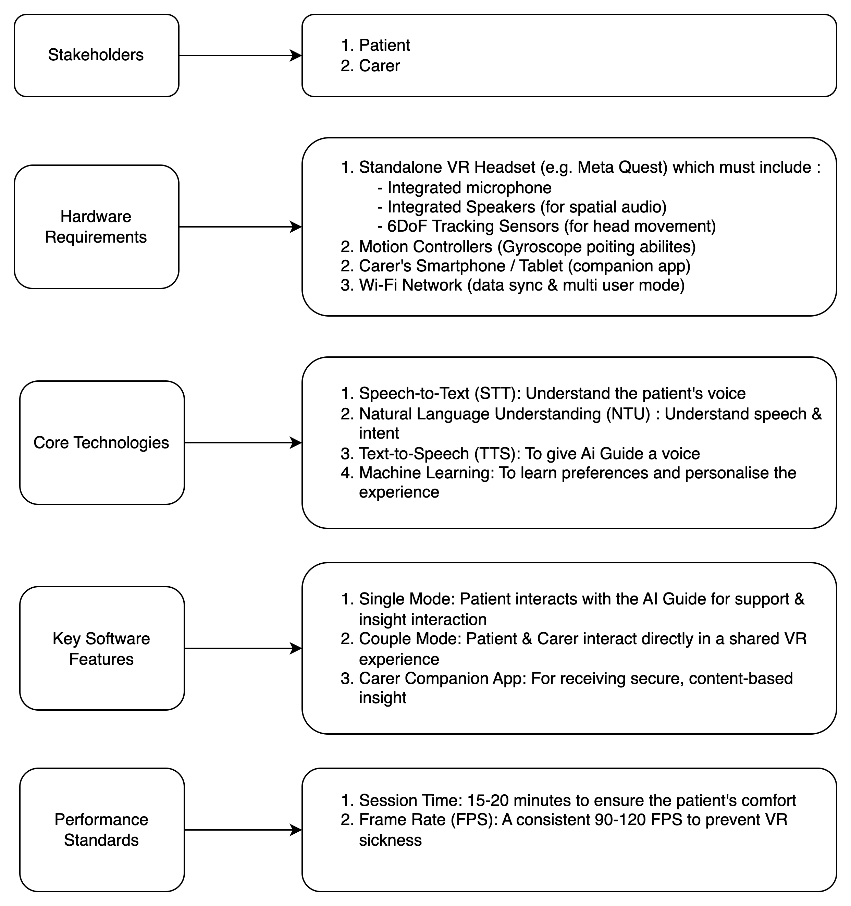

**User Journey Flowchart**

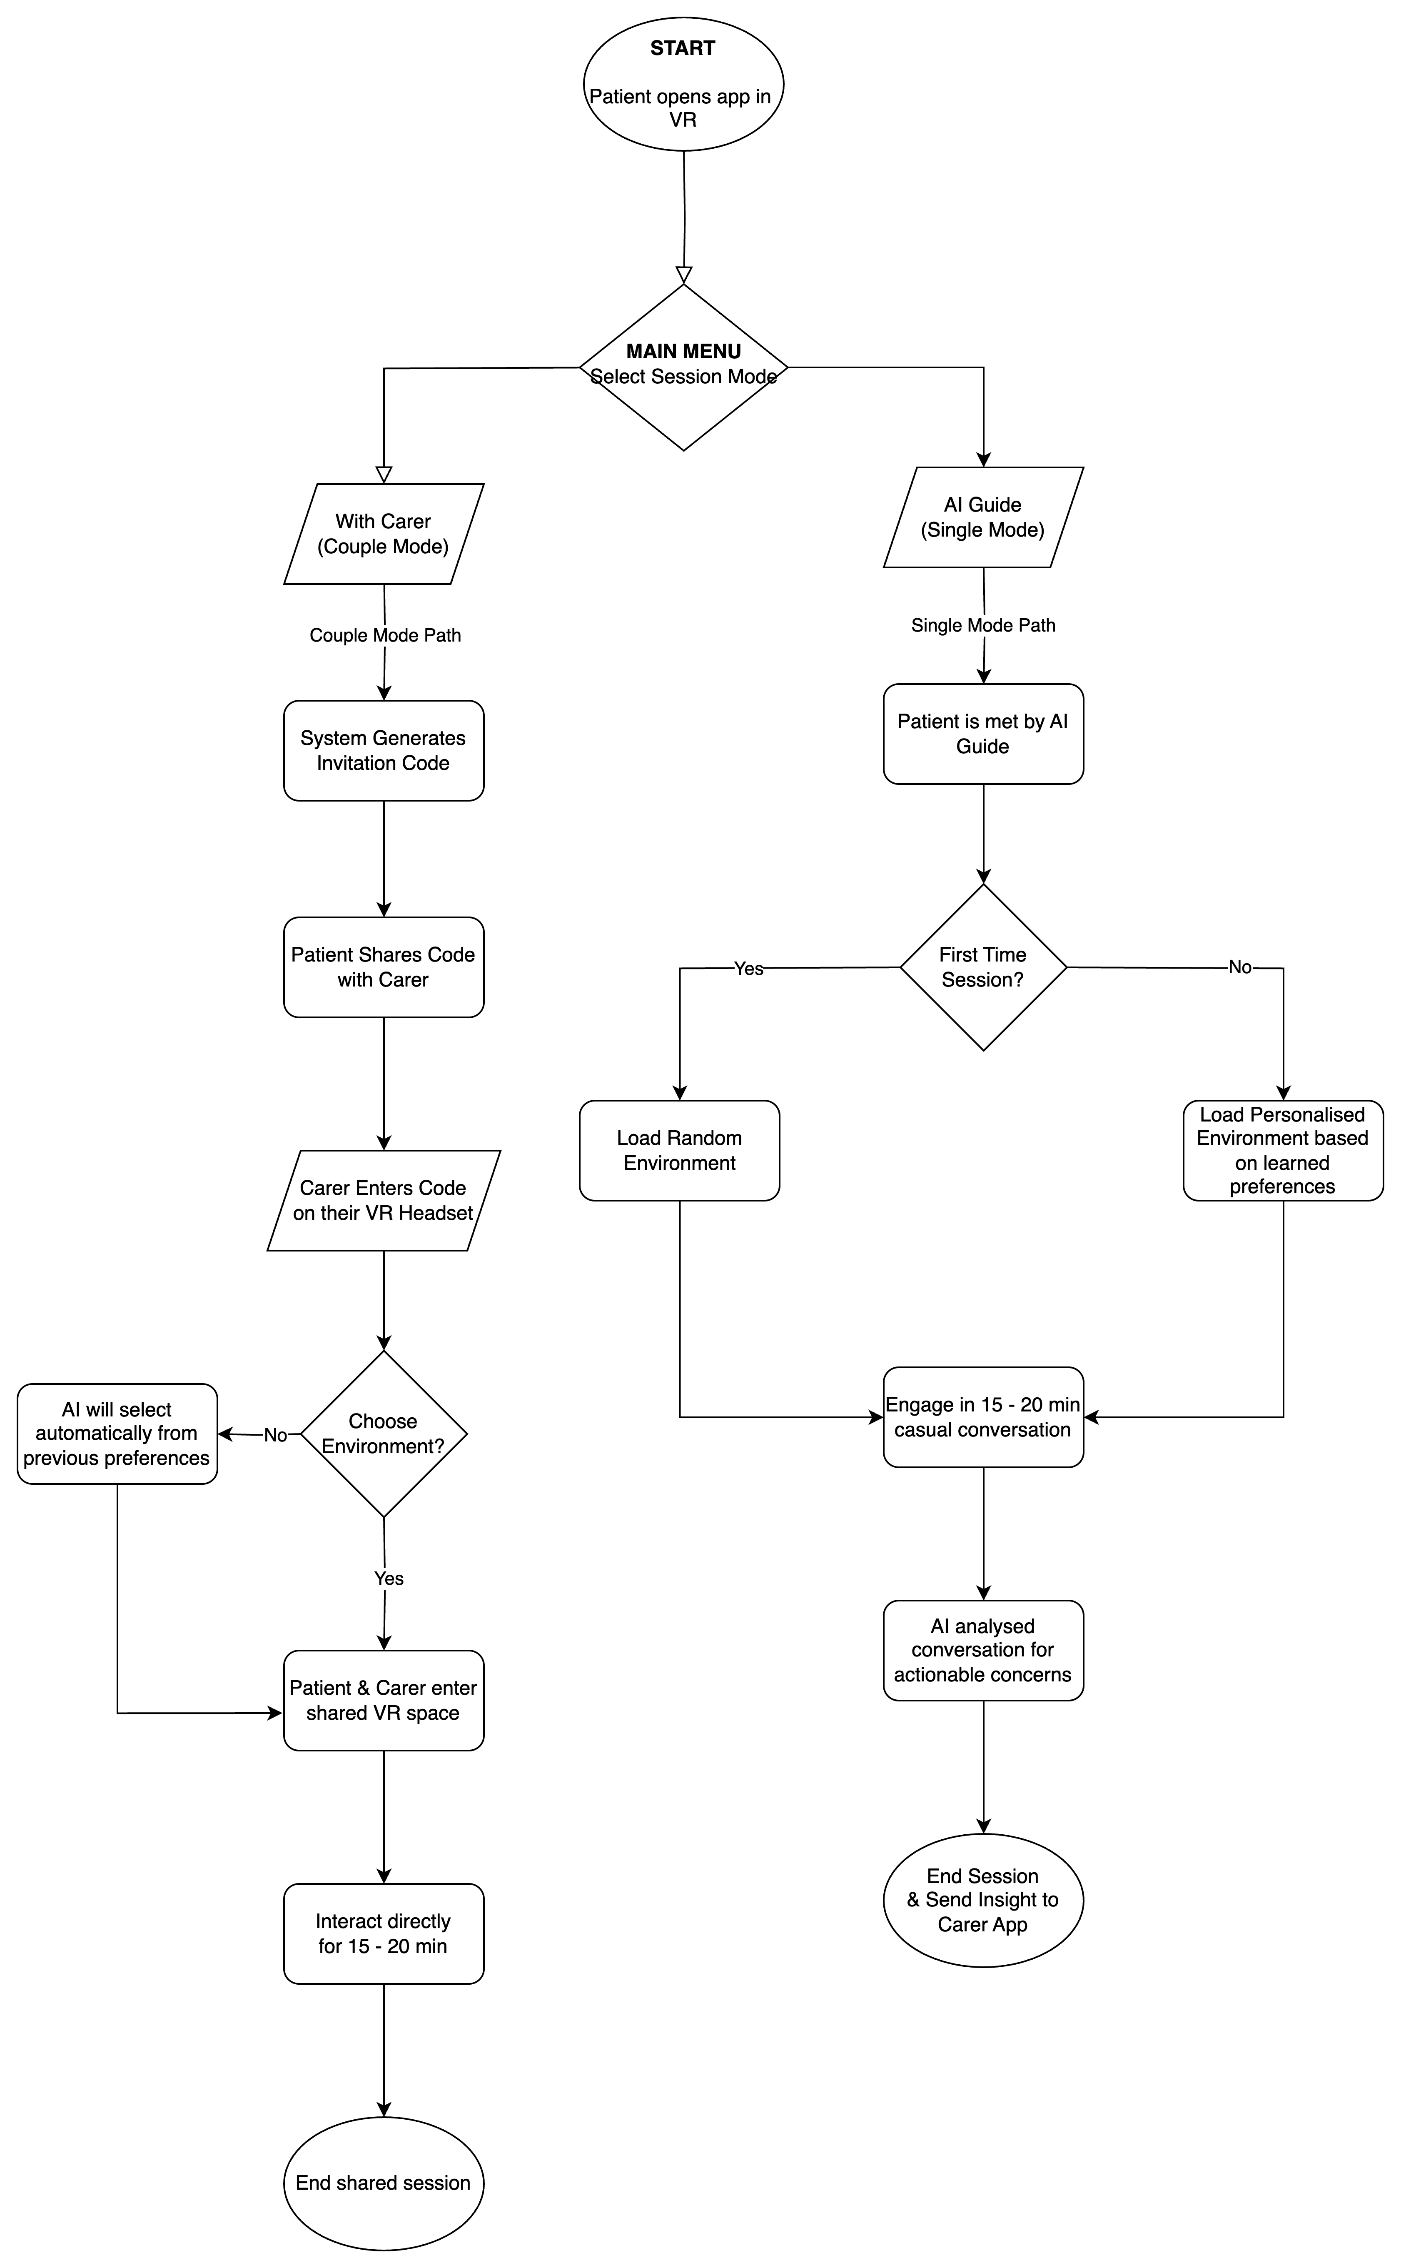

**Key Aspect 3: Ethical considerations:**

|  |  |
| --- | --- |
| **Poster** | **Presentation** |
| * Compliance with WHO digital health governance (WHO, 2021) and GDPR/HIPAA data-protection standards (EU, 2016; US Congress, 1996). * Adherence to the Declaration of Helsinki (WMA, 2013), the Belmont Report (National Commission, 1979) and UNESCO bioethics principles (UNESCO, 2005). * Integrate explicit informed-consent and proxy-consent processes to protect patient autonomy and care-giver involvement. * Ensure end-to-end encryption, secure cloud storage and strict access controls for all sensitive data. * Affordable standalone headsets and inclusive features (e.g. screen-mirroring) to promote equitable access. * Regular algorithmic audits for fairness and transparency (IEEE Ethically Aligned Design, 2020; ISO/IEC 22989, 2021). * Follow human-centred design and duty-of-care protocols to prioritise user safety, dignity and well-being. | Our product will comply with the WHO digital health governance framework and meet GDPR and HIPAA standards, ensuring robust privacy and data security. It will adhere to the Declaration of Helsinki, the Belmont Report and UNESCO’s bioethics guidelines to uphold respect for persons, beneficence and justice. We will integrate explicit informed-consent and proxy-consent processes, allowing patients and their care givers to provide or withdraw consent at any stage. All sensitive data will be encrypted end-to-end, stored securely in the cloud, and protected by strict access controls. To promote equity, we will deploy affordable standalone headsets with inclusive features such as screen-mirroring for care-giver participation.  A key innovation is our AI’s ability to perform thematic analysis on patient–care-giver dialogue, extracting actionable data points on physical comfort and environmental safety(is this correct @Vinda? Anything to add?). Regular algorithmic audits—guided by IEEE and ISO AI standards—will ensure transparency and mitigate bias. Finally, our human-centered design and duty-of-care protocols will prioritise safety, dignity and continuous product improvement Words 166 |

**Future Trends**

|  |  |
| --- | --- |
| Poster | Presentation |
| * Data from patient–care-giver interactions will feed a registry-based learning health system—under robust consent—that supports large-scale, multi-centre palliative-care outcomes studies and continuously refines VR content (Kamal et al., 2018; Demuro et al., 2024). * Telepalliative care via telehealth platforms will enhance access, independence and safety for home-based patients (Kirby et al., 2025). * Emerging XR and haptic technologies—such as AR-assisted life-review and simulated touch—will deepen immersion, improve mood, lessen anxiety and foster presence and belonging (Eckhoff et al., 2022). * An AI-driven care-giver dashboard could aggregate patient metrics, automate reminders and issue predictive alerts to reduce cognitive load and decision fatigue (Borna et al., 2024). * Real-time well-being monitoring—via brief surveys or passive sensor data—could detect care-giver stress or burnout and trigger tailored VR respite sessions (Ordu et al., 2024) * Peer-support VR lounges will allow care-givers to share synchronous experiences and coping strategies, fostering community, security and resilience (Patano et al., 2024).   (Words 154)   * (@Salman please check this box, do you think we should say anything else here? Anything we should delete? I think you should speak this section?) | Looking forward, our platform can power a registry-based learning health system that not only fuels large-scale palliative-care research but also uses anonymised interaction data to adapt VR content over time (Kamal, Demuro). Telepalliative care integration is rising, bringing treatment into patients’ homes and boosting independence (Kirby). At the same time, XR and haptic advances—like AR life-review and simulated touch—will deepen emotional engagement, improve mood, lessen anxiety and enhance presence (Eckhoff). For care-givers, we envision an AI-driven dashboard to reduce cognitive load (Borna), real-time stress monitoring to trigger VR respite (Ordu) and peer-support VR lounges to build community and resilience (Patano ). Words 103 |

**Conclusion**

|  |  |
| --- | --- |
| Poster | Presentation |
| * Our integrated AI–VR platform bridges siloed technologies while embedding ethical, privacy and consent safeguards to enable data-driven palliative-care research. * Future integration of telehealth and XR will expand reach, personalise experiences and deepen emotional support. * Our vision is a scalable, learning health ecosystem that continuously improves quality of life and outcomes in palliative care. (could be a paragraph if it looks better)   Words: 54 | In summary, our integrated AI–VR platform bridges previously siloed technologies, embedding robust ethical, privacy and consent safeguards to enable powerful data-driven palliative-care research. Looking forward, we will incorporate telehealth and extended-reality features to broaden access, personalise therapeutic experiences and deepen emotional support. Our immediate next steps are to build a working prototype, launch multi-centre pilot studies to assess clinical impact and usability, and refine the system iteratively using feedback from patients and care givers. Ultimately, we envision a scalable learning-health ecosystem that continuously evolves—improving quality of life and outcomes for all those in palliative care. Words 100 |

References

Altman, M. A., Smith, J. L. & Doe, R. (2024) ‘Personalized VR sessions in palliative care: Reducing symptom burden and improving quality of life’, *Journal of Palliative Medicine*, 27(2), pp. 101–110.

Deming, L., Brown, A. & Chen, S. (2024) ‘Nature-based 360° videos for symptom relief in hospice patients’, *Palliative Care Research*, 10(1), pp. 15–23.

Guo, J., Dai, Y., Jiang, S., Liu, J., Xu, X., Chen, Y., et al. (2025) ‘Machine learning model for prediction of palliative care phases in patients with advanced cancer: a retrospective study’, *BMC Palliative Care*, 24:148. doi:10.1186/s12904-025-01785-4

Narvaez, P., Lee, Y. & Patel, K. (2025) ‘AI-driven distress surveillance in palliative care: A systematic review’, *International Journal of Medical Informatics*, 150, pp. 200–212.

Narvaez, R. A., Lee, Y., Patel, K., et al. (2025) ‘Artificial intelligence in symptom management and clinical decision support for palliative care’, *International Journal of Palliative Nursing*, 31(6), pp. 294–306. doi:10.12968/ijpn.2025.0041

Knaul F M, Arreola-Ornelas H, Kwete X J, Bhadelia A, et al. The evolution of serious health-related suffering from 1990 to 2021: an update to The Lancet Commission on global access to palliative care and pain relief. Lancet Glob Health. 2025 Mar;13(3):e422–e436. doi:10.1016/S2214-109X(24)00476-5

Migiddorj, B., Wang, X. & Kumar, S. (2025) ‘Transparency gaps in AI models for distress monitoring’, *IEEE Journal of Biomedical and Health Informatics*, 29(4), pp. 567–576.

World Health Organization (2021) *WHO digital health governance: Principles and tools for national strategies*. Geneva: World Health Organization.

European Union (2016) *Regulation (EU) 2016/679: General Data Protection Regulation (GDPR)*. Brussels: European Parliament.

United States Congress (1996) *Health Insurance Portability and Accountability Act (HIPAA)*. Washington, D.C.: U.S. Government Publishing Office.

World Medical Association (2013) ‘Declaration of Helsinki: Ethical principles for medical research involving human subjects’, *JAMA*, 310(20), pp. 2191–2194.

National Commission for the Protection of Human Subjects of Biomedical and Behavioral Research (1979) *The Belmont Report: Ethical Principles and Guidelines for the Protection of Human Subjects of Research*. Washington, D.C.: U.S. Government Publishing Office.

United Nations Educational, Scientific and Cultural Organization (2005) *Universal Declaration on Bioethics and Human Rights*. Paris: UNESCO.

IEEE Global Initiative on Ethics of Autonomous and Intelligent Systems (2020) *Ethically Aligned Design: A Vision for Prioritizing Human Well-being with Autonomous and Intelligent Systems*. Piscataway, NJ: IEEE.

International Organization for Standardization (2021) *ISO/IEC 22989: Information technology — Artificial intelligence — Concepts and terminology*. Geneva: ISO.

Alanazi, M.O., Patano, A., Bente, G., Mason, A., Goldstein, D., Parsnejad, S., Wyatt, G. and Lehto, R. H. (2023) ‘Nature-based virtual reality feasibility and acceptability pilot for caregiver respite’, *Current Oncolog*,* 30(7), pp. 5995–6005. doi:10.3390/curroncol30070448

Borna, S., Maniaci, M.J., Haider, C.R., Gomez-Cabello, C.A., Pressman, S.M., Haider, S.A., Demaerschalk, B.M., Cowart, J.B. and Forte, A.J. (2024) ‘Artificial Intelligence Support for Informal Patient Caregivers: A systematic review’, *Bioengineering*, 11(5), p. 483. doi:10.3390/bioengineering11050483

Demuro, M., Bratzu, E., Lorrai, S. and Preti, A. (2024) ‘Quality of life in palliative care: a systematic meta-review of reviews and meta-analyses’, *Clinical Practice & Epidemiology in Mental Health*, 20(Suppl-1), p. e17450179183857. doi:10.2174/0117450179183857240226094258

Eckhoff, D., Ng, R. and Cassinelli, A. (2022) ‘Virtual reality therapy for the psychological well-being of palliative care patients in Hong Kong’, [Preprint]. Available at: [https://arxiv.org/abs/2207.11754](https://arxiv.org/abs/2207.11754)

Kamal, A.H., Currow, D.C., Casarett, D.J. and Abernethy, A.P. (2018) ‘A person-centered, registry-based learning health system for palliative care: a path to coproducing better outcomes, experience, value and science’, *Journal of Palliative Medicine*, 21(Suppl 1), pp. S35–S42. doi:10.1089/jpm.2017.0354

Kirby, A., Griffin, D., Heavin, C., Drummond, F.J., McGrath, C. and Kiely, F. (2025) ‘Telehealth adoption in palliative care: a systematic review of patient barriers and facilitators’, *BMC Palliative Care*, 24(1), p. 52. doi:10.1186/s12904-025-01698-2

Ordu, Y., Demirci, Y., Ünal, Ö. and Gümüş, E. (2024) ‘The effect of using virtual reality goggles on psychological well-being and care burden of informal caregivers of patients hospitalized in a palliative care clinic’, *European Journal of Oncology Nursing,* 73, p. 102711. doi:10.1016/j.ejon.2024.102711

Patano, A., Alanazi, M.O., Lehto, R.H., Goldstein, D. and Wyatt, G. (2024) ‘A nature-immersive virtual reality intervention to support hospice family caregivers: qualitative findings from a pilot study’, *Asia-Pacific Journal of Oncology Nursing* 11(12), p. 100616. doi:10.1016/j.apjon.2024.100616